ASCOM OpenWeatherMap Driver
Summary
This driver implements the AsCOM ObservingConditions interface using the OpenWeatherMap internet API as a data source.

Installation
Run the installer.

Operation
Use the Chooser to select the OpenWeatherMap ObservingConditions driver.
Click on Properties to run the Setup Dialog.
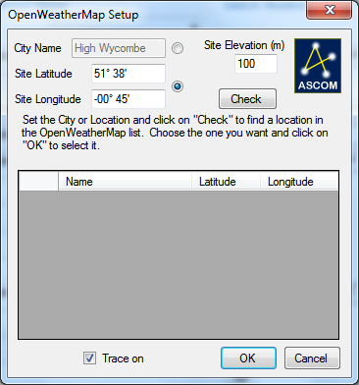
Check either the CiyName or Location radio buttons and type in an appropriate city name or location.
Click on “Check” to check that the values you set are OK and you should get up to 5 entries showing a location, latitude and longitude.
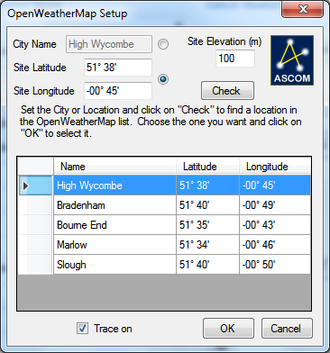
Click on the one you like and click on OK.
Connect to the driver. It may take a few seconds to get good data returned.

